1. What were the top songs for the past 10 years and their respective artists?

SELECT song_name,

artist,

year

from datasets.billboard_top_100_year_end

where year >= 2008 and year_rank=1

group by year, song_name, artist

order by year

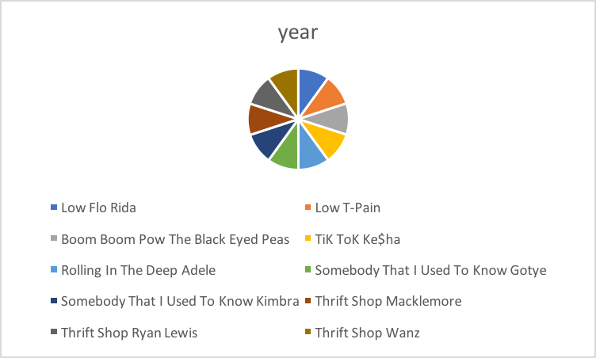

1. Which songs were the most popular in the last 10 years and their respective artists?

SELECT song_name,

count(song_name),

artist

from datasets.billboard_top_100_year_end

where year >= 2008 and year_rank <= 20

group by song_name, artist

order by count DESC

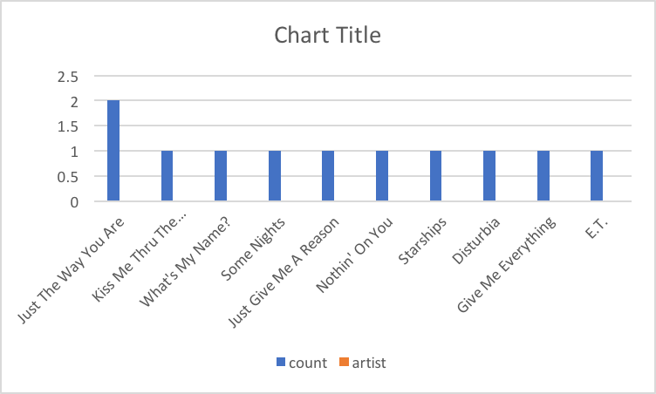

3. Which songs were the most popular in the last 50 years and their respective artists?

SELECT song_name,

count(song_name),

artist

from datasets.billboard_top_100_year_end

where year >= 1968 and year_rank <= 8

group by song_name, artist

order by count DESC

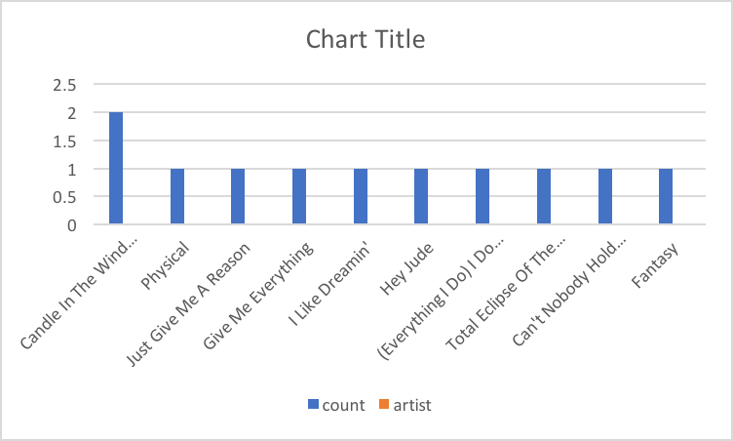

4.

SELECT nominee,

count(nominee) as times

from datasets.oscar_nominees

GROUP by nominee

order by times DESC

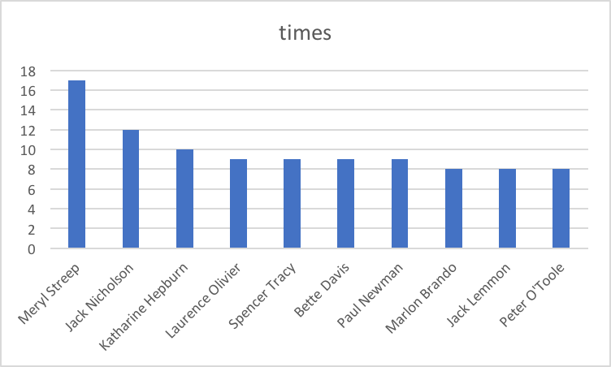

5.

SELECT winner,

count(winner)

from datasets.oscar_nominees

GROUP by winner

